Name: Tula Dutta Joshi

Age: 59

Sex: Male

Disease: Type 1 Diabetes (Insulin reliant)

**Body Measurement**

Height: 171 cm (5ft 7 inches)

Weight: 60 kg

Ideal Weight: 66 kg

Weight to be gained: 6 kg

|  |  |
| --- | --- |
| Cal Needs for Men > 50 years | Cal Needs for Women > 50 Years |
| Not Active about 2000  Moderate active 2200-2400  Active 2400-2800 | Not Active about 1600  Moderate active 1800  Active 2000-2200 |

Total amount of Cal required = 2400 Kcal per day (From Above table)

*Protein = 1 gm per kg*

Amount of protein required = 66 gm

Cal from protein = 66 x 4 = 264 kcal

Cal from Carbs and fat = 2400 kcal – 264 kcal = 2136 kcal per day

*1 gm Carbs contain 4 kcal*

Cal from Carbs only = 2136/2 = 1068/4 = 257 gm

*1 gm Fats contain 9 kcal*

Cal from Fats only = 2136/2 = 1068/9 = 118.66 gm ~ 119 gm

**Serving Size**

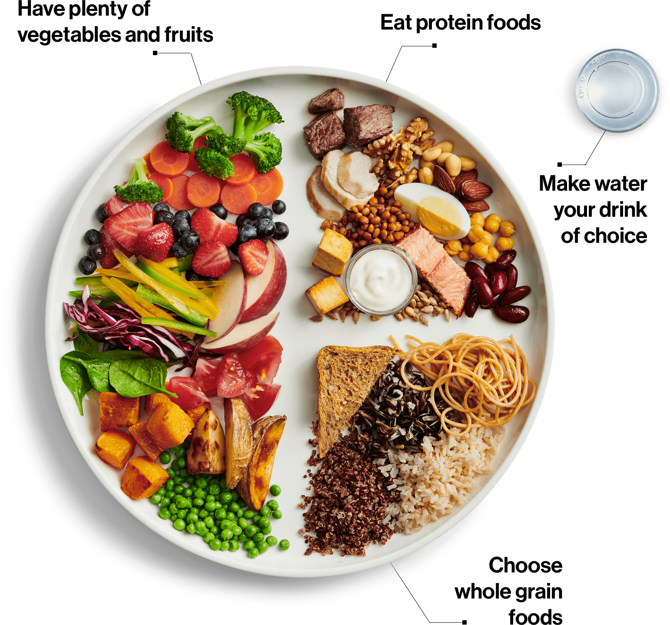

Total Calores from Carbs

1/5 for Breakfast = 1/5 of 1068 = 213.6 kcal ~ 214 kcal

2/5 for Lunch = 2/5 of 1068 = 427.2 kcal ~ 427 kcal

2/5 for Dinner = 2/5 of 1068 = 427.2 kcal ~ 427 kcal

OR

Equal Distribution

1/3 for Breakfast = 1/3 of 1068 = 356 kcal

1/3 for Lunch = 1/3 of 1068 = 356 kcal

1/3 for Dinner = 1/3 of 1068 = 356 kcal

Total Calores from Fats

1/5 for Breakfast = 1/5 of 1068 = 213.6 kcal ~ 214 kcal

2/5 for Lunch = 2/5 of 1068 = 427.2 kcal ~ 427 kcal

2/5 for Dinner = 2/5 of 1068 = 427.2 kcal ~ 427 kcal

OR

Equal Distribution

1/3 for Breakfast = 1/3 of 1068 = 356 kcal

1/3 for Lunch = 1/3 of 1068 = 356 kcal

1/3 for Dinner = 1/3 of 1068 = 356 kcal

**Meat Exchange**

Calorie -70

Protein -10 g

|  |  |
| --- | --- |
| Food | Quantity |
| Mutton | 60 g |
| Chicken | 60 |
| Fish | 60 |
| Egg | 2 Nos |

**Vegetable A exchange**

|  |  |
| --- | --- |
| Broccoli | Kerau |
| Karela | Farsi ko Munta |
| Cabbage | Egg plant |
| Corinders | Cauliflower |
| Spinach | Rayo ko Saag |

**Vegetable B exchange**

Calorie -50

Carbohydrates-10g

|  |  |
| --- | --- |
| vegetables | Quantity |
| Cucumber | 75 g |
| Carrot | 105 g |
| Potato | 45 g |
| Sweet potato | 30 g |
| Mula | 45 |

**Fruit's exchange**

Calorie -50

Carbohydrates-10g

|  |  |
| --- | --- |
|  | Papaya - 120 g |
| Apple - 75 g | Peach - 135 g |
| Banana - 30 g | Pear - 90 g |
| Grapes - 105 | Pineapple - 90 |
|  |  |
| Lemon - 90 g | Pomegranate -75g |
| Mango - 90 g |  |
| Melon - 270 g | Tomato - 240 g |
| Orange - 90 g |  |

**Cereal exchange**

Calorie -100

Carbohydrates-20g

Protein- 2g

|  |  |
| --- | --- |
| Rice | Each 30 g provides 100 Calories |
| Barley |
| Maize |
| Cornflakes |
| Oatmeals |
| Beaten rice |
| Maida |
| Atta |
| Millet |

**Fat exchange**

Calorie -100

Fat - 11 g

|  |  |
| --- | --- |
| Food | Quantity |
| Almond | 15 g |
| Butter | 15 g |
| Coconut | 30 g |
| Ghee | 11 g |
| Ground nut | 20 g |
| Oil | 11 g |
| Walnut | 15 g |

**Meal Planning for Diabetes**

|  |  |  |  |  |  |
| --- | --- | --- | --- | --- | --- |
| **Item** | **No of exchange** | **Calories Kcal** | **Carbohydrates g** | **Protein g** | **Fat g** |
| **Milk** | **2** | **200** | **10** | **8** | **10** |
| **Legumes& pulse** | **2** | **200** | **30** | **12** | **-** |
| **Meat** | **1** | **100** | **-** | **10** | **13** |
|  |  |  |  |  |  |
| **Veg. A** | **2** | **Approx**  **100** | **Approx**  **25** | **4** | **-** |
| **Veg. B** | **2** | **50** | **10** | **-** | **-** |
| **Fruits** | **1** | **50** | **10** | **-** | **-** |
| **Cereals** | **3** | **300** | **60** | **6** | **-** |
| **Fat** | **2** | **200** | **-** | **-** | **22** |
|  |  | **~1200 Kcal** | **145 g** | **40g** | **45g** |

Meal plan for the day ( 1/3, 1/3 1/3 calories from carbohydrates

Tea

1 cup tea (Suger free + Ginger)

Breakfast

1 Exchange milk (180 ml)- 100 Kcal

1 exchange cereal(oatmeal)- 30 g -100Kcal

1 exchange fruit (Medium sized) (apple) - 50 Kcal

Total calorie= 310 Kcal

Carbohydrates= 35 g

Lunch

1 Exchange cereal (30 g)- 100 Kcal (Rice)

2 exchange veg. A

1 exchange Veg. B (30-75 g) - 50Kcal

1 exchange fat (11 g)- 100 Kcal (sunflower oil)

1 Exchange legumes and pulse (30 g)- 100 Kcal (dal)

Total calorie= 400 Kcal

Carbohydrates= 35 g

Dinner

1 Exchange cereal (30 g)- 100 Kcal (roti)

2 exchange veg. A

1 exchange Veg. B (30-75 g) - 50Kcal

1/2 exchange fat (5 g)- 50 Kcal (sunflower oil)

1 Exchange legumes and pulse (30 g)- 100 Kcal (dal)

1 egg = 70Kcal

Bed time

1 glass milk without sugar- Carbohydrates (4 g)

Total calorie= 400 Kcal

Carbohydrates= 45 g

Final Verdict:

1. Since data wasn’t taken before head. Above calculation are just approximation.
2. Overall, in Nepali's diet consist of carbohydrates/Cereals which takes more space than any other food. Even for the diabetes patient.
3. No balance diets
4. 2400 cal should be taken but only 1200 cal was there #DONOT take it seriously